Custom Training

Day 3

**Azure SQL**

**Creation of resource group and resource:**

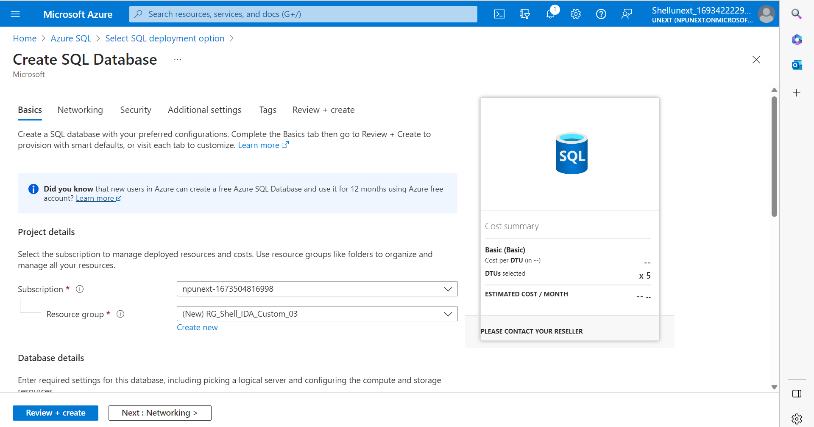

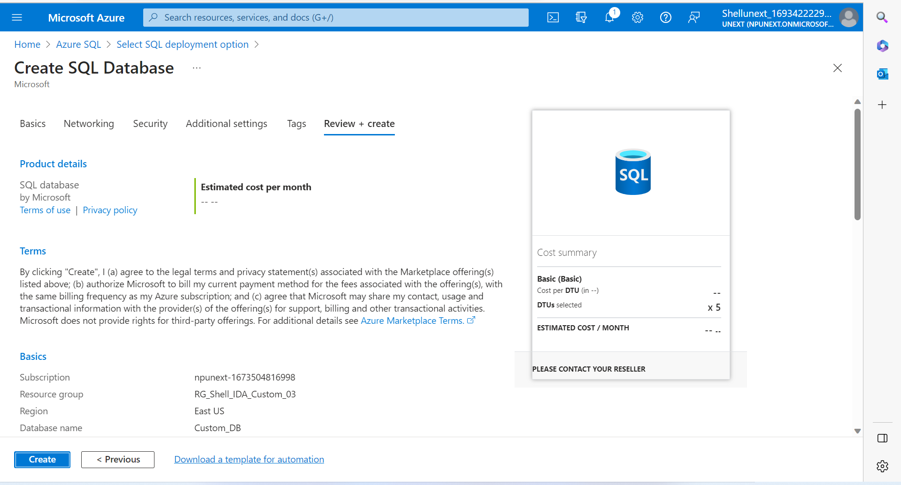

*Connection Policy:

* + Default: For the users /client connection inside the azure
  + Proxy – Database provided through gateways because there is no connection access of the user/client inside azure.
  + Redirect – In this the client doesn’t have azure connection but it directly establishes connection to the node to access db.

*Transport Layer Security is used whenever the data is being transferred to secure it.

*Minimum TLS Version – Choose the latest.

**TABLES**

**View : Limited access of table**

CREATE VIEW view_name AS  
SELECT column1, column2, ...  
FROM table_name  
WHERE condition;

* **DDL :** Data definition
* **DML:** Data Manipulation
* **DCL:** Data Control
* **TCL:** Transaction Control

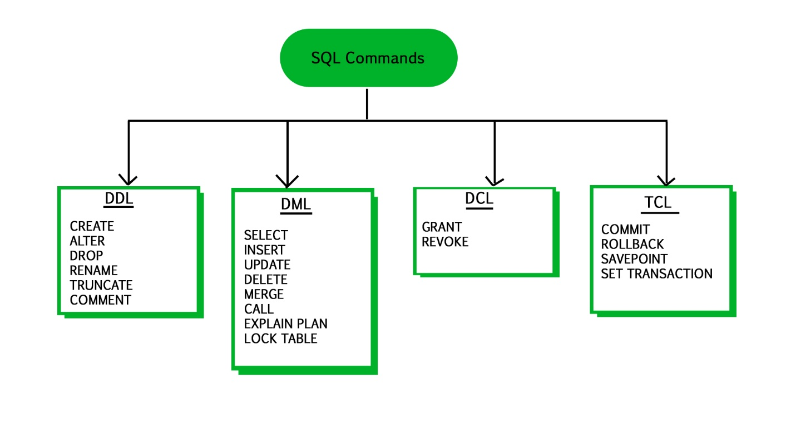

**Schema:** Logical grouping of table objects

**Default Schema: dbo**

If we write select without creating schema, if dbo is there it will search for dbo and if not there it will throw error .

If there is any project schema , first find out that

E.g.,

Create schema ven1

Create table ven1.vendor

**SYNTAX:**

CREATE SCHEMA schemaname

E.g.,

CREATE SCHEMA book_store;

SELECT *

FROM sys.schemas

**Difference between Drop table, delete table and truncate table**

* **Drop Table:** Entire record and structure will be delete
* **Delete Table:** Selects rows/records will be deleted
* **Truncate Table:** All the records will be deleted but structure will be there.

**\***Only difference between delete and truncate is that where clause can be put in delete that is selected records can be deleted.

Server -> Databases -> Tables -> Schemas